 | The Welsh NHS Confederation response to Plaid Cymru's manifesto development.
Contact: | Nesta Lloyd-Jones, Assistant Director, Welsh NHS Confederation  Nesta.Lloyd-Jones@WelshConfed.org
Date: | 11 October

About us
- The Welsh NHS Confederation (WNHSC) welcomes the opportunity to provide information to Plaid Cymru as part of your manifesto process.

- The Welsh NHS Confederation is the only national membership body representing all the organisations making up the NHS in Wales: the seven Local Health Boards, three NHS Trusts (Velindre University NHS Trust, Welsh Ambulance Services NHS Trust and Public Health Wales NHS Trust), and two Special Health Authorities (Digital Health and Care Wales and Health Education and Improvement Wales). The twelve organisations make up our members. We also host NHS Wales Employers.

- Our response highlights the key calls that are being developed by the NHS Confederation on behalf of members across England, Wales and Northern Ireland and the key issues for our members in Wales, highlighted in our recent briefing The NHS at 75: How do we meet the needs of future generations?. While health and social care is devolved in Wales, areas such as immigration, social security and the regulation of medicines and the workforce are not, and these can impact on health services, Welsh Government and the Senedd.

NHS Confederation
- The NHS faces significant challenges across the UK, whether it is the number of people on waiting lists for elective treatment, current staff vacancies across health and care, the need for investment in NHS estates and equipment, public health or supporting people with complex needs. NHS leaders across England, Wales and Northern Ireland know they cannot tackle these complex challenges alone and must work with others, including local authorities, the voluntary sector and community care providers to support people to enjoy the best possible health and wellbeing.

- The NHS Confederation is developing its manifesto priorities and engaging with members across England, Wales and Northern Ireland. While still being developed, and aimed at the UK Government, the areas that we want the next UK Government to prioritise include:
- Building the health of the nation: The next UK Government must see health policy as wider than NHS policy. The health needs of people are influenced by factors outside the NHS, including good housing, education, environment, transport, and NHS leaders want to see a cross-government approach that creates the conditions for everyone to enjoy the best possible health.
- Putting the NHS on a more sustainable footing: The NHS requires immediate stabilising interventions to allow space for local health leaders to think in the longer-term rather than continual firefighting.
- Facilitating the most efficient and effective ways of working across the service: The underfunding of NHS capital has led to buildings, digital infrastructure and equipment falling into a state of disrepair across many health settings, including hospital estates, GP surgeries, community and mental health services.
- NHS workforce: The next UK Government must ensure they build a health and care workforce that can meet population need and respond to changing demographics. NHS leaders know that the social care workforce faces even bigger challenges and needs political attention and priority.
- Provide more care closer to home: Political focus and resource must shift to provide the conditions for more people to be treated at an earlier stage of illness and within their own community. We need to proportionately shift resources out of acute hospitals and upstream into community-based services, primary care and prevention.

Key areas for NHS leaders in Wales
- Amplifying the five themes outlined in paragraph 5, NHS leaders across Wales have identified the following priority areas for political and public action.
- The need for a national conversation.
- Need for a National Health and Care Service.
- The need to promote staff wellbeing, develop cross-sector skills and review the overlapping layers of regulation.
- Need for long-term financial certainty and investing in Welsh communities.
- Need for one public service.
- Reshaping the public’s relationship with the NHS and embedding population health.
- Quality-based outcomes focusing on public experience across health and care.
- Need for a cross-government approach to reducing poverty and inequalities.
- Building a digitally ready workforce.
- Getting value for money from the NHS.

Future of health and care services
Our call: The need for a national conversation
- Health and care systems across the world are under considerable pressure and face significant challenges which all political parties and Governments across the UK need to work together to respond to.

- As highlighted in a recent report, the NHS in Wales, and wider public sector and communities, will face a number of challenges over the next 10 to 25 years. The infographic below provides a summary of the key projections from the report and why bold decisions need to be made around care pathways, the types and location of treatments and allocation of resources to ensure they are spent in areas that maximise benefit relative to population needs.

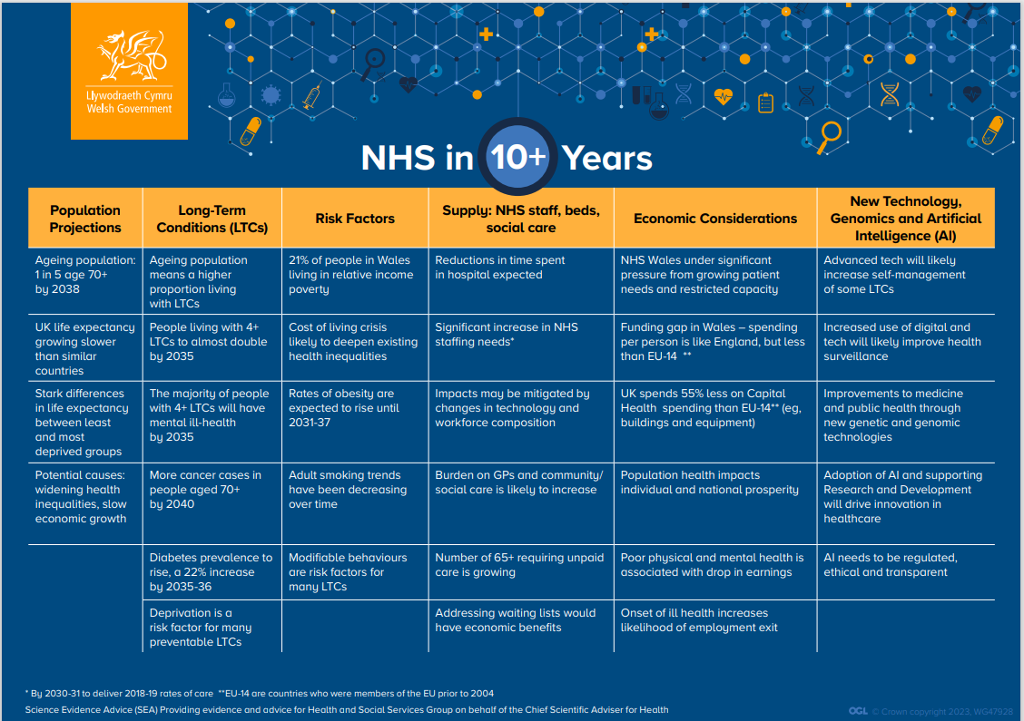
- Due to the current pressures on the health and care system, now is the time to galvanise the Welsh public to engage in a national conversation on how the health and care system can innovate and transform to meet the needs of future generations as set out in our recent briefing, The NHS at 75: How do we meet the needs of future generations?

- The public must feel personally invested in their wellbeing and our health and care service to help ensure its long-term sustainability, which will only be possible through public involvement and co-production of services. This will allow people to feel supported, empowered and informed to take more responsibility for their health and wellbeing, manage their conditions and use services responsibly.

Sustainability of the social care sector
Our call: Need for a National Health and Care Service
- The health and social care sector is facing tremendous pressure, which is subsequently impacting the ability of the NHS and social care providers in Wales to continue delivering services.

- Social care services play a crucial role in care pathways – keeping people well for longer outside of hospital and enabling faster, safer discharges home. Therefore, the sector plays a critical part in protecting NHS capacity and its ability to deliver high-quality, safe care. However, social care services are facing significant challenges, including vulnerabilities in funding and market stability, increased demand, growing unmet need and high levels of staff vacancies. The impact of these challenges means people are missing out on vital care and support, leaving them less independent, more vulnerable and more likely to rely on healthcare services.

- The NHS is reliant on a sustainable social care system, and capacity and workforce issues in social care are having serious implications on the NHS’ ability to discharge large numbers of clinically optimised patients from hospital. At the time of writing, there are around 1,500 patients in Wales who were clinically optimised and ready for discharge. This has the equivalent impact on bed capacity to shutting the University Hospital of Wales in Cardiff.

- As highlighted in our briefing from last year, "It's not just a crisis, it's a national emergency": Addressing the challenges in social care, the key areas to support the sustainability of the health and care system includes:
- Preventing hospital admissions. Given the significant challenges to patient flow and the potential and actual harm that results from a prolonged hospital stay, it is essential that as many people as possible are supported in their own community rather than in a hospital. Efforts across the health and care system are therefore focused on reducing avoidable hospital admissions.
- Discharge to Recover and Assess. It is clear that assessing patients in hospital for ongoing and often long-term care can underestimate the ability of individuals to recover and improve. This can result in an over-provision of care and in some cases set a pattern of long-term care that becomes irreversible. A systematic approach to discharging patients from hospital to assess their strengths (strength-based approaches are becoming more widely enacted in practice) and identify care and support requirements is a major element of development across Wales.
- Workforce. It is important to recognise that workforce supply is critical. Whilst recruitment efforts are important, engaging, developing and supporting staff to aid retention is fundamental. Some of the developments therefore are focused on supporting staff and look to reduce or manage the risk of ‘robbing Peter to pay Paul’, and simply move staff between health and social care.
- Broadening care and support approaches. This focuses on widening the approaches to the provision of care and support, including working with the voluntary sector and families. It also looks to flex the role of some elements of the care system to meet local pressures.

Workforce
Our call: The need to promote staff wellbeing and developing cross-sector skills and review the overlapping layers of regulation.
- The health and care workforce is at the heart of how we deliver care and services to patients and their families. The NHS is Wales’ biggest employer, currently directly employing over 100,000 people, and Social Care Wales estimate that over 29,000 people work in adult residential care in Wales in 2022. Together with volunteers and unpaid carers, the health and social care workforce impacts on the social, cultural and economic prosperity of Wales.

- At present, the health and care workforce is designed to deliver services to outdated models and patterns of care. Previously, care has been modelled around treatment of single conditions, but with an ageing population and increasing co-morbidities, people often require long-term care from health and social services. The skills and capacity of the workforce is a major determinant of the quality of care and outcomes.

- As well as meeting the future needs of the population, the workforce must develop new ways of working to manage an expected shortfall in future NHS and social care staff levels. We must acknowledge that maintaining and developing the current workforce is just as important as growing and training a new one. The impact of the pandemic and post-pandemic pressures on staff morale needs to be considered as staff struggle with moral injury due to feeling they are unable to provide adequate care. Social Care Wales estimate that between 2021 and 2022 there was a 4.6 per cent drop in the estimated workforce over the 12 months period, from 30,531 in 2021 to 29,100 in 2022.

- We need to continue to promote staff wellbeing, delivering agile and improved ways of working for staff and volunteers. We must also plan for a sustainable and resilient workforce to better match changing demand and more digitally delivered services. Developing staff roles and skills is key to providing complex, multi-disciplinary, co-ordinated care in partnership with individuals, cross-sector partners and communities.

- While significant work is being done, the current age profile and demographics in Wales, like other parts of the UK, mean the workforce may not exist by 2035 to operate health and care in its current format.

- The 2011 and 2021 census demonstrate the changes by age band, with the over 65 population up 17.7 per cent, and a general fall in younger age bands. It is estimated that by 2035 there will be 18.1 per cent fewer entering the workforce.

Population changes – age bands 2011 to 2021 Census

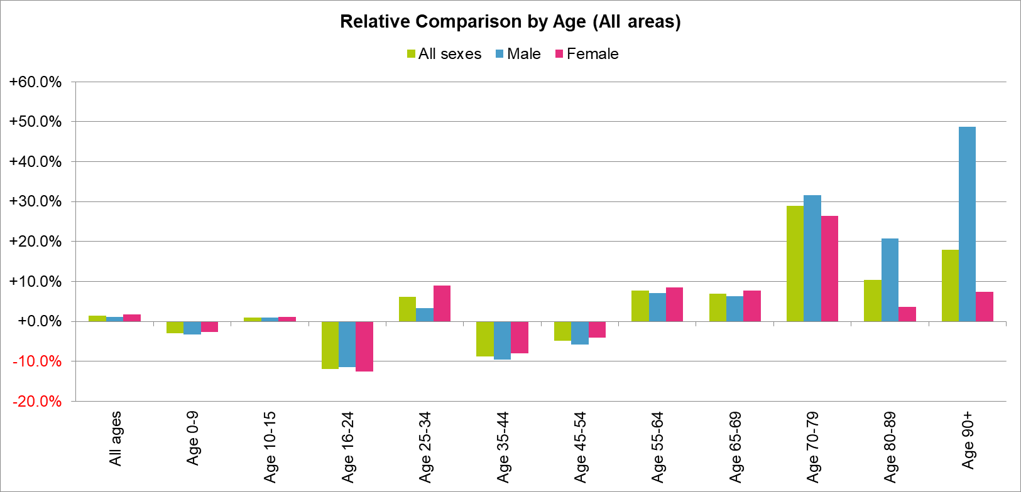

- Healthcare faculties are subject to regulation from health and education sectors. Better join-up between regulators would avoid competing demands on educators, streamlining reporting and enhance safety.

Funding
Our call: Need for long-term financial certainty and investing in Welsh communities.
- As highlighted in the Welsh NHS Confederation report, 'Investing in the NHS: Priorities for future government budgets’ (2022), the rise in demand, coupled with constrained financial resources, has made delivering health and care in the current model increasingly difficult. It is therefore essential for the sustainability of the NHS that the population engage in maintaining their own health and wellbeing.

- As is well documented, NHS organisations are facing unprecedented financial challenges, with the seven health boards forecasting a deficit this financial year (2023-24). They have been impacted by a range of external drivers; increased inflation, energy costs and the resulting cost of living crisis, lower growth, demand on services following the pandemic and staff recruitment and retention issues.

- While there are vast financial challenges across public services, long-term financial certainty is needed from the UK and the Welsh Government. Short term funding fixes or small-scale amendments to the edges of service delivery will not suffice if we are to address the serious financial challenges we face. Indeed, the House of Lords Select Committee report into the long-term sustainability of the NHS, published in June 2018, cites three key objectives if the NHS is to make real progress towards a sustainable health and care system. These are defined as: radical service transformation; long-term funding solutions; and immediate and sustained action on adult social care.

Health and social care interaction
Our call: Need for one public service.
- Integration is a means to an end – providing patients with a seamless service at the right time and in the right place. It is about getting all parts of the system to work together so people receive timely, efficient and effective care that brings about the outcome that matters most to them. To achieve this, we need to get services working seamlessly across professional boundaries: health and social care; primary and secondary care; and physical and mental health, and the digital infrastructure to enable this to happen. More broadly, improving population wellbeing and reducing demand on services requires an integrated approach as it depends on the provision of good social care, housing, education, community amenities, digital infrastructure and an environment that actively promotes and encourages people to live healthy lives.

- There is a need for one public service across Wales. Health and care are becoming more integrated across all public bodies and the health and wellbeing of the population is not the sole responsibility of the NHS; everyone must come together and play their part. Access to healthcare only accounts for around 10 per cent of a population’s health, with the rest being shaped by socio-economic factors (The Health Foundation, 2017). Collaborative working and integration of services within and outside of the health and care service is vital to provide person-centred care. Partnership working cannot be prescribed or governed, instead it is based on strong relationships, brought together through a shared purpose.

- Improving population health and wellbeing requires an integrated approach across services and sectors. We must support and empower the whole public, private and third sector to work seamlessly across organisational boundaries, ensuring the right governance structure, leadership, outcome measures and financial support is provided to design and deliver effective, simple and person-centred services.

- All sectors have a role to play in creating a preventative model and collectively we need to create the economic, social and natural environment in Wales to support good health and wellbeing throughout the life-course. This requires good housing, education, social care, transport, access to the arts and leisure, community support and an environment that actively promotes and encourages people to live healthy lives.

- Although the health and care system is complex, Wales has a golden opportunity to achieve so much when it comes to designing and delivering integrated person-centred services due to its size, structure and strong working relationships.

Responding to the public health challenges
Our call: Reshaping the public’s relationship with the NHS and embedding population health
- Wales faces a significant number of population health challenges which stall life expectancy and widens inequalities. This includes high levels of obesity, unhealthy alcohol consumption, smoking and poor levels of physical activity. The most recent National Survey for Wales results shows that 13 per cent of adults currently smoke, 16 per cent drink more alcohol than the recommended guidelines, only 36 per cent reported a healthy weight and 56 per cent reported that they had been physically active in the previous week. The impact of such behaviours is resulting in greater demand on health services, as well as to the public purse.

- As highlighted in our report ‘Reshaping the relationship between the public and the NHS’, we need to reshape the public’s relationship with the NHS and support people to look after their own health and wellbeing. This will require the government to redirect resources towards long-term investment in public engagement and communication and introduce a Deal for Health and Wellbeing. The Deal must clearly set out what the public and staff are entitled to from the NHS, the contributions that the public can make to their own health and wellbeing and how services can be co-produced with the public, delivering on ‘what matters’ to people.

Performance targets across the NHS and social care
Our call: Quality-based outcomes focusing on public experience across health and care
- Waiting times are an important measure of whether patients can really access the comprehensive healthcare the NHS promises. However, saving lives and preserving the health of the population are the ultimate goals of a healthcare system. The current NHS targets sharply focus on secondary care and do not always support the system to grow and redesign, such as by moving services into primary and community care settings.

- While targets have a role to play, we must also look at the bigger picture, instigating whole system change in the way prevention and health promotion is prioritised, treatment is delivered, how services are provided, and how population health is measured.

- It is vital that meaningful, person-centred performance measures and frameworks are developed across health and social care, and wider public sector. These should focus on patient experience, value-based healthcare, clinical outcomes, prevention and whole-system collaboration.

Inequalities
Our call: Need for a cross-government approach to reducing poverty and inequalities
- Health inequalities – unfair and avoidable differences in health and access to health and care across the population, and between different groups within society – have been exacerbated by the COVID-19 pandemic and the rising cost of living.

- Audit Wales has recently called poverty the single major challenge facing all tiers of Welsh Government. Wales has the highest poverty rate among the four UK nations, with over a third of children (34 per cent) classed as living in poverty. Inequality has a broad adverse effect on societal wellbeing, as has been demonstrated across a range of measures, including health, life expectancy, crime, and mental health. It is estimated that health inequalities costs the Welsh NHS £322 million every year.

- A report by Public Health Wales in 2022 analysed life expectancy and healthy life expectancy since 2011 to 2020. It highlighted that the gap in life expectancy between the least and most deprived populations in Wales has been generally increasing in recent years for males and females, suggestive of growing inequality. The inequality gap was over a year greater for males than in females. The gap in healthy life expectancy has remained relatively stable between 2011-2013 and 2018-2020 for males and females. The gap in females was over three and a half years larger than for males.

- The current 20-year gap in health life expectancy between our wealthiest and poorest communities is significant. It is the consequences of inequality that mean a greater number of citizens require our services.

- Some possible explanations cited for worsening health expectancies and widening inequalities include low wage growth, fuel poverty, food insecurity, and the period of austerity in Wales since 2010/11 as highlighted by Sir Michael Marmot. The recent rise in the cost of living is an additional pressure which may further increase inequalities in health expectancies as lower income households may not be able to afford basic necessities such as food and heating to maintain a decent standard of living.

- The NHS alone does not have all the levers to reduce health inequalities, which is why we need to shift the focus from public health initiatives delivered through the NHS and local authorities to addressing factors such as poor housing, green spaces, transport and food quality. As highlighted in the Welsh NHS Confederation Health and Wellbeing Alliance and Royal College of Physicians report, ‘Mind the gap: what’s stopping change?, addressing the factors that cause ill health in the first place should be a central focus for the Welsh Government and we must continue to relentlessly focus on improving population health in order to reduce health inequalities. There needs to be a whole cross-government and public service approach to inequalities and the Welsh Government should produce a cross-government plan for reducing poverty and inequalities in adults and children.

Embracing technology
Our call: Building a digital capacity and a digitally ready workforce
- If the health and care system is to realise its ambitions, it must maximise the strategic and operational potential of digital technology as an enabler of change. Digital technologies can support the NHS and social care professionals to predict poor health; detect early deterioration and illness sooner; diagnose more precisely; and make better and more informed choices about which treatment and care is right for the individual.

- The pandemic has given us an opportunity to make significant progress in the use of digital skills and technology, and we must not lose momentum. We must ensure that no part of the workforce is digitally excluded, and we must make the most of opportunities to invest in infrastructure and a skills development programme. Learning through digital platforms needs to be accessible, and bitesize learning opportunities help with this approach. It creates greater equity of access, as does the use of mobile technology.

- Digital technology should be considered one of the most significant strategic tools available to shift to a preventative model of health and social care – a model which will help to reduce demand on secondary care and social care services by keeping people healthier for longer. There are many examples that demonstrate some of the ways in which the NHS and local government are trying to embrace digital technology e.g. NHS Wales app which supports patients to better manage their own health and wellbeing and digitally connecting them to the health and care system; electronic test request, the Welsh Nursing record, National Data Resource and the use of text messaging services to support individuals with chronic conditions; or the establishment of online forums for unpaid carers.

- We need to adopt a whole-system approach to digital transformation and to be explicit about what should be done locally and what could be done nationally. There needs to be further investment in technology and skills to use and share data to provide insight to drive improvements, for example the national data resource which has recently been available now provides an opportunity to bring data together in a way that was not possible previously. By focusing on the service user, and with the explicit aim of increasing self-care and service outcomes, organisations can review their internal processes and redesign them. This would remove duplication and waste to create an operational model with digital technology embedded through and across whole organisations. We also need to recognise that current public finance constraints mean NHS organisations and local government in isolation do not have the scale of investment needed to transform and integrate the whole system. Increase investment in IT infrastructure is vital to enable full use of digital applications and increase cyber security.

NHS contribution to the economy
Our call: Getting value for money from the NHS
- While there are vast financial challenges across public services, we need to increase awareness of the NHS’s contribution to the economy.

- Spending money on the NHS is not just about plugging gaps. Health spending drives innovation and growth in communities across Wales. Our briefing ‘Health, wealth and wellbeing: The NHS’ role in economic and social recovery’ highlights the numerous ways the NHS helps support the economy, including as a large employer, a key purchaser of goods and services, and a capital estate holder and developer. Recent analysis by Carnall Farrar shows that for each £1 spent per head on the NHS, there is a corresponding return on investment of £4.

Conclusion
- The Welsh NHS Confederation welcomes the opportunity to engage with Plaid Cymru as part of your manifesto development process and would be pleased to provide further information and meet with Plaid Cymru's Director of Policy, Heledd Fychan MS, to discuss further.

